|  |
| --- |
| C:\Users\Muthomi\Pictures\Random\logo%2016th%20Sept.png |
| **UNIVERSITY OF NAIROBI**  **FACULTY OF ENGINEERING**  **DEPARTMENT OF ELECTRICAL & INFORMATION ENGINEERING** |
| **Design and Implementation of a Solar-Powered Smart Microgrid for Rural Electrification in Kenya** |
|  |
| **MSc Thesis Proposal** |
|  |
| **STUDENT NAME** |
| **BSc Electrical Eng (University of Nairobi)** |
| **FEE6/12345/2025** |
| **A thesis proposal submitted in partial fulfilment of the requirements for the award of the Degree of Master of Science in Electrical and Electronic Engineering of the University of Nairobi** |
| **JULY 2025** |

Template updated: 2025-07-28

[DELETE THIS TEXT BOX]

DECLARATION AND APPROVAL

|  |  |  |  |  |  |
| --- | --- | --- | --- | --- | --- |
| This thesis proposal is my original work. I also affirm that to the best of my knowledge; this has not been presented for a degree in any other university. | | | | | |
| Name: **Student Name** | | | [studentname@students.uonbi.ac.ke](mailto:studentname@students.uonbi.ac.ke) | | |
| Registration Number: | | **F56/12345/2025** |  | |  |
| Signature: | ………………………………… | | Date: | …………………………… | |
| This thesis proposal is submitted for examination with our approval and knowledge as university supervisors: | | | | | |
| **SUPERVISORS** | | | | | |
| **Dr. Supervisor A. One** | | | [supervisorone@uonbi.ac.ke](mailto:supervisorone@uonbi.ac.ke) | | |
| Signature: | ………………………………… | | Date: | …………………………… | |
| **Dr. Supervisor B. Two** | | | [supervisortwo@uonbi.ac.ke](mailto:supervisortwo@uonbi.ac.ke) | | |
| Signature: | ………………………………… | | Date: | …………………………… | |
| **DEPARTMENT OF ELECTRICAL & INFORMATION ENGINEERING** | | | | | |
| **CHAIRMAN** | | | [dept-elec@uonbi.ac.ke](mailto:dept-elec@uonbi.ac.ke) | | |
| Signature: | ………………………………… | | Date: | …………………………… | |
| **FACULTY POSTGRADUATE STUDIES COMMITTEE (FPSC)** | | | | | |
| **CHAIRMAN** | | |  | | |
| Signature: | ………………………………… | | Date: | …………………………… | |
| **FACULTY OF ENGINEERING** | | | | | |
| **DEAN** |  | |  |  | |
| Signature: | ………………………………… | | Date: | …………………………… | |

**UNIVERSITY OF NAIROBI**

DECLARATION OF ORIGINALITY

|  |  |  |  |  |  |  |
| --- | --- | --- | --- | --- | --- | --- |
| Student Name: | | Student Name | | | | |
| Registration Number: | | FEE6/12345/2025 | | | | |
| Faculty/School/Institute: | | Faculty of Engineering | | | | |
| Department: | | Department of Electrical & Information Engineering | | | | |
| Course Name: | | Master of Science in Electrical & Electronic Engineering | | | | |
| Title of Work: | | Design and Implementation of a Solar-Powered Smart Microgrid for Rural Electrification in Kenya | | | | |
|  | | | | | | |
| 1. I understand what plagiarism is, and I am aware of the university policy in this regard. 2. I declare that this thesis is my original work and has not been submitted elsewhere for examination, the award of a degree or publication. Where other works or my own work has been used, this has properly been acknowledged and referenced in accordance with the University of Nairobi’s requirements. 3. I have not sought or used the services of any professional agencies to produce this work. 4. I have not allowed and shall not allow anyone to copy my work to pass it off as his/her work. 5. I understand that any false claim in respect of this work shall result in disciplinary action in accordance with University of Nairobi anti-plagiarism policy. | | | | | | |
| Signature: | …………………………... | |  | Date: | ………………………... |  |

ACKNOWLEDGEMENT

It is required to acknowledge any assistance rendered during the study. Supervisors should be acknowledged first. Use active language. The role of the people mentioned should be mentioned. For example, I would like to thank my supervisors, Dr. Supervisor One and Prof. Supervisor Two for guiding this research. Secondly, I would like to thank Eng. Tutor for motivating me to pursue a master’s degree.

TABLE OF CONTENTS

DECLARATION AND APPROVAL i

DECLARATION OF ORIGINALITY ii

ACKNOWLEDGEMENT iii

TABLE OF CONTENTS iv

LIST OF TABLES v

LIST OF FIGURES vi

ABBREVIATIONS vii

ABSTRACT viii

CHAPTER ONE 1

1. INTRODUCTION 1

1.1 Background of the Study 1

1.2 Problem Statement 1

1.3 Research Objectives 1

1.4 Scope 1

1.5 Definition of terms (If necessary) 2

CHAPTER TWO 3

2. LITERATURE REVIEW 3

2.1 Introductions 3

2.2 (Last section) Implication/Synthesis of Literature Review/Knowledge Gaps 4

CHAPTER THREE 5

3. METHODOLOGY 5

3.1 Overview of Methodology 5

3.2 Description of Study area (If descriptive) 5

3.3 Steps 5

3.4 Expected Results or Outcomes 5

CHAPTER FOUR 6

4. WORK PLAN AND BUDGET 6

4.1 Work Plan 6

4.2 Budget 7

4.3 Secured Funding 8

4.4 Publications (If necessary) 8

REFERENCES 9

APPENDICES 11

Appendix A: Mould Fabrication Drawings 11

LIST OF TABLES

Table 4.1: Budget breakdown 7

The list of Tables should start on its own page. The caption should have the topic in which it is located. For example, the first table in the fourth chapter will be named "Table 4.1”. Only a period separator should be used, hyphen separators such as “Table 4-1” shold not be used.

LIST OF FIGURES

Figure 4.1: Work plan of the intended activities. 6

Charts, Images, graphs, illustrations, photographs, and plates should be in the List of Figures. There should be no separate lists for each.

List of Figures should start on its own page. The caption should have the topic in which it is located. For example, the first figure in the fourth chapter will be named "Figure 4.1”. Only a period separator should be used, hyphen separators such as “Figure 4-1” should not be used.

There should be no list of equations, even though the equations in the main body of the proposal should be numbered.

ABBREVIATIONS

Should start on its own page. The abbreviations should be listed in alphabetical order. There should be no hyphen between the abbreviations and its meaning. See the sample abbreviations below. Use tables then hide the borders to achieve the desired effect.

|  |  |
| --- | --- |
| AAR | alkali-aggregate reaction |
| ANOVA | Analysis of Variance |
| ASR | alkali-silica reaction |
| BS | British Standard |

ABSTRACT

The abstract shall be short and concise, a maximum of one page and one paragraph. Its contents should include the issue, what will be studied (objectives), and how it will be done (methodology). Typically, the abstract does not have citations. The ‘Abstract’ appears just before the ‘Introduction’; although unusual, this placement of the abstract is the University standard.

**Notes to the Template**

Please note this template is only for guidance and you should adhere to your supervisor’s advice. The initial pages take advantage of tables for formatting. To edit the first pages, highlight the table and turn the borders on to see the table lines. Take advantage of the ‘Styles’ palette in the ‘Home’ ribbon of Microsoft Office to format this thesis proposal document.

For the subsequent chapters, please note the heading title must first be centre-aligned and written in words ‘CHAPTER ONE’ and not ‘CHAPTER 1’. The numbered headings (with Arabic numerals) should be left-aligned as presented in this proposal template. The paragraph text throughout should be justified even though APA requirements state that the text should be left-aligned.

One the cover page, below the student’s name, ensure that you have your **undergraduate** qualification and not the master’s programme you are currently on.

Under no circumstances should the main body of this proposal exceed 30 pages. The main body of the proposal consists of: Introduction, Literature Review, Methodology, Workplan & Budget and References.

CHAPTER ONE

# INTRODUCTION

## Background of the Study

This section shall provide a brief overview of the proposed area of study. It should inform the reader what the study will be about and why it is important and timely (McKenzie, 2013). The last paragraph should state in general what the proposed study will do to address the issue. The background should not exceed two pages and should not include details such as tables, figures or lists. The headings should be left aligned.

## Problem Statement

This section should recap the background information identifying the gaps in knowledge or problems to be addressed in the study. The statement should be concise and presented in one paragraph not exceeding one page. It should end with a statement of therefore what needs to be done to address the problem.

## Research Objectives

Objectives should be to fill the gap in knowledge highlighted in the Background Information and the Problem Statement by creating an understanding of the issue, and not a set of activities. The “Overall” or “General” objective should be stated first followed by specific objectives.

There should be at least three specific objectives. All objectives should be deductive. Use terms such as ‘characterise, ‘evaluate’, ‘establish’, and ‘compare’. Do not use terms that are mere tasks such as ‘determine’, ‘assess’ and ‘identify’ or vague such as investigate or study. The specific objectives are presented in a numbered list after an opening statement. The use of unnumbered bullets is discouraged in academia.

## Scope of the Study

Scope of work indicates the depth of research; how deep/far the study will be involved in the subject area, which geographical area, source of material, where testing will take place. Clear study boundaries (limits) should be included as well as study variables.

## Definition of Terms (If necessary)

**Smart Microgrid**: A decentralized energy system that integrates renewable generation (e.g., solar PV), energy storage (e.g., batteries), and intelligent control mechanisms (e.g., IoT sensors, machine learning algorithms) to optimize power distribution autonomously. Unlike traditional grids, smart microgrids can operate in both grid-connected and islanded modes, enabling resilience and efficiency in rural electrification (Bhattacharya & Roy, 2022).

CHAPTER TWO

# LITERATURE REVIEW

## Introduction

This section shall present information on the evolution and present state of theory, practice and research of the topic proposed for investigation. A candidate is expected to demonstrate review of most recent and relevant publications which must be properly cited in the references. This section may be organized with subheadings to represent different areas of emphasis. Reference in text should be cited as follows: These results are similar to those that were found by Wismer and Luth (1973). It was also seen by Kepner *et al.* (1972). It is believed the approach took effect from the mid-1900s (Odo *et al.*, 1999; Wire, 2001; Luti, 2010). Or if information is obtained from the website, then the url address and date of access should be included ([www.ojose.com](http://www.ojose.com), accessed on 12th December 2011). Ideally, URL links should have Digital Object Identifiers (DOIs). The student is encouraged to use citation managers such as Zotero.

Figures should be centred, and figure caption placed below the figure as shown in Figure 2.1. Figures should be numbered according to the chapter and have a period separator and not a hyphen separator. Figures should be referred in the text by their caption title and not the words “below” and “above”.

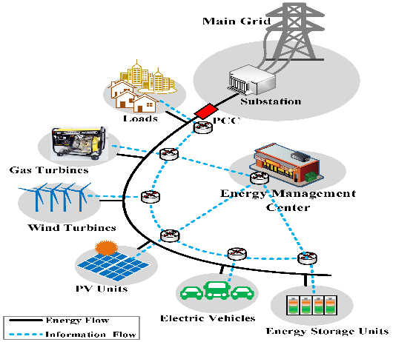

Figure 2.1: Smart microgrid

Equations should be aligned to the left and equation number aligned to the right. All equations should be numbered systematically throughout with the first figure referencing the chapter and the second the serial number of the equation. Equation 2.1 was developed by Otieno et al. (2023) for microgrids in Sub-Saharan Africa:

$s=a^{x}+\cos\left(θ\right)*\frac{dy}{dx}$ (2.1)

Table title and number should be put above the table as shown in Table 2.4. Tables should be numbered according to the chapter and have a period separator and not a hyphen separator. Tables should be referred in the text by their caption title and not the words “below” and “above”.

Table 2.4: Types of remote sensing sensors

|  |  |  |
| --- | --- | --- |
|  |  |  |
|  |  |  |

## (Last section) Implication/Synthesis of Literature Review/Knowledge Gaps

Include knowledge gaps.

CHAPTER THREE

# METHODOLOGY

Briefly but accurately explains how you performed your research in a logically organized manner. This section should be sufficiently detailed to allow the reader to duplicate the important aspects of your methods. It is quite common for this section to contain labelled subsections dealing with apparatus, materials and specific procedures used. It establishes the credibility of your methodology or the lack of it. Commercially available pieces of apparatus may be described in terms of their commercial labels while specially constructed apparatus needs to be described in greater details. Highlights of the expected outputs should also be given.

## Overview of Methodology

Provide an overview of the procedures.

## Description of Study Area (If descriptive)

Provide description of study area including location maps and coordinates.

## Steps

Provide the steps in the methodology.

## Expected Results or Outcomes

Include some expected results or outcomes.

CHAPTER FOUR

# WORK PLAN AND BUDGET

## Work Plan

The work plan should indicate the duration of planned activities in a logical sequence. The plan should be for post-proposal acceptance activities. Only items in the future should be included in the proposal. Items in the past should be discarded. The work plan should be communicative, legible, and simple. The table should use grey colour, and the activity column should be left aligned. The work plan should also be in portrait as shown in Figure 4.1. It should be noted that the work plan is a figure and not a table and should be captioned as a figure.

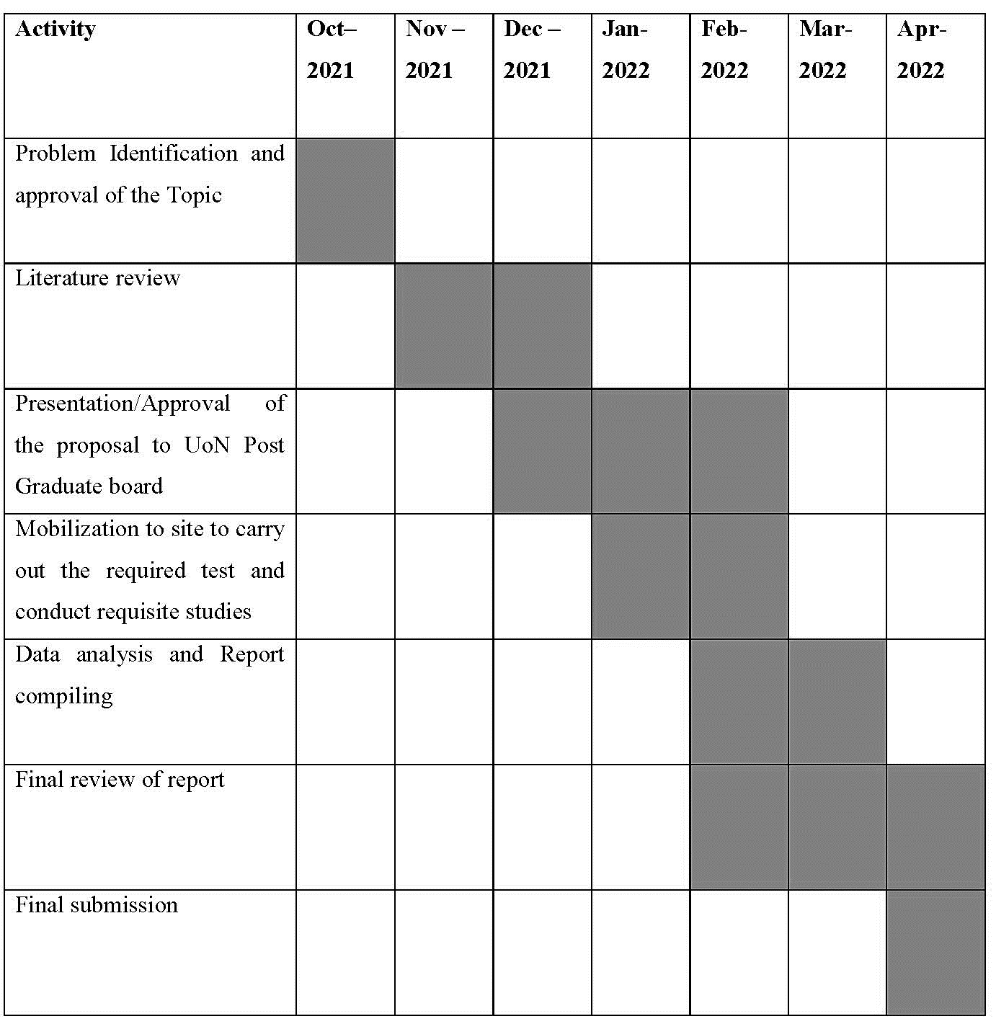

Figure .: Work plan of the intended activities.

The work plan should not be less than six months.

## Budget

The budget shall be based on all envisaged activities of the proposed study. It shall comprise costs relevant to the above activities, including all the materials and contingencies.

The cost of conducting this experimental programme is estimated to be Kenya Shillings 790,900 only. It should be on its own page. The breakdown is shown in Table 4.1.

Table .: Budget breakdown

| No. | **Item** | **Proposed Amount** |
| --- | --- | --- |
| 1 | **INTRODUCTION** | |
| 1.1 | Report writing | 10 000.00 |
| 1 | **Sub-total** | **10 000.00** |
| 2 | **LITERATURE REVIEW** | |
| 2.1 | Literature and reports purchase | 10 000.00 |
| 2.2 | Internet | 24 000.00 |
| 2 | **Sub-total** | **34 000.00** |
| 3 | **TRANSPORT & COMMUNICATION** | |
| 3.1 | Professional consultation | 10 000.00 |
| 3.2 | Communication charges | 5 000.00 |
| 3.3 | Site Visits | 45 000.00 |
| 3 | **Sub-total** | **60 0000.00** |
| 4 | **COMPONENTS ACQUISITION** | |
| 4.1 | PV Panels (300W x 4) | 90 000.00 |
| 4.2 | Li-ion Batteries (48V, 100Ah) | 190 000.00 |
| 4.3 | IoT Sensors (Raspberry Pi) | 10 000.00 |
| 4 | **Sub-total** | **290 000.00** |
| 5 | **SOFTWARE AND EQUIPMENT** | |
| 5.1 | MATLAB | 200 000.00 |
| 5.2 | PYTHON | 15 000.00 |
| 5 | **Sub-total** | **215 000.00** |
| 6 | **DOCUMENTATION & DISSEMINATION** | |
| 6.1 | Drafts | 10 000.00 |
| 6.2 | Printing of reports | 20 000.00 |
| 6.3 | Stationery | 15 000.00 |
| 6.4 | Final report and copies | 15 000.00 |
| 6.5 | Dissemination – Paper Presentation & Conferences | 50 000.00 |
| 6 | **Sub-total** | **110 000.00** |
| 7 | **TOTAL** | **719 000.00** |
| 7 | CONTINGENCIES (10%) | 71 900.00 |
| 8 | **FINAL SUM** | **790 900.00** |

A breakdown of some of the costs of the material is discussed in Appendix C.

## Secured Funding

Indicate potential sources of funding. Funding is available from the university through application of grants. A list of all available grants is on the university’s website <https://uonresearch.uonbi.ac.ke/> under the funding tab.

## Publications (If necessary)

This section should include some peer-reviewed journals in which publications of the study can be made. This section should also mention the publishing times of the journal and the cost (if any). Guidelines on how to publish are outlined in an audio-visual presentation by the Library Department:

<https://www.youtube.com/watch?v=Nug7iyVkFIo&ab_channel=UONLibrary%26InformationServices> and a website article <https://uonlibrary.uonbi.ac.ke/node/348>.

REFERENCES

The references are not a chapter, and it should therefore not be numbered. The method of citing the studies include the authors’ names and the year of publication of cited literature are used in the text, in citing the literature, thus: “These results are similar to those that were found by Wismer *et al.* (1973) and by Kepner *et al.* (1972)”. In the references section, the cited references are then listed, without numbering but in proper alphabetical order, as shown below:

**Articles in journals**

Benediktsson J. A. and I. Kanellopoulos (1999). Classification of Multisource and Hyperspectral Data Based on Decision Fusion, *IEEE Transactions on Geosciense and Remote Sensing,* 37(3): 1367-1377.

**Reports**

Craglia, M. and A. Annoni (2003). *The Spatial Impact of European Union Policies*, EUR 20121 EN, Ispra: European Communities.

**Chapters in Edited Volumes**

Licklider J.C.R. (1960). "Quasi–linear operator models in the study of manual tracking", in Duncan R. L. (Ed). *Developments in Mathematical Psychology: Information, Learning, and Tracking*. Glencoe, Ill.: Free Press, pp. 167–279.

**Web-based articles**

Peterson R.E. (1997). Eight Internet Search Engines Compared, *First Monday,* 2(2) (February), at http://firstmonday.org/issues/issue2_2/peterson/, [accessed 14 December 2001].

**Proceedings**

Riecken, J., Bernard, L., Portele, C. and A. Remke (2003). “North-Rhine Westphalia: Building a Regional SDI in a Cross-Border Environment / Ad-Hoc Integration of SDIs: Lessons learnt”, *Proceedings 9th EC-GI & GIS Workshop ESDI, June 25-27 2003, Coruña, Spain,* pp. 13-56. Ispra: European Communities.

**Books**

Soille, P. (1999). *Morphological Image Analysis - Principles and Applications*, Berlin: Springer Verlag.

This method of presenting reference is known as the APA citation style – 7th Edition.

**Sample List of References below:**

Arduini, M., Tommaso, A. D., Manfroni, O., Ferrari, S., & Romagnolo, M. (1999). The passive confinement of elements compressed in concrete with sheets of composite material. *The Italian Cement Industry*, *69*(748), 836–841.

Associated Press. (2019, December 6). *Building collapses in Kenya, unknown number trapped in debris*. South China Morning Post. https://www.scmp.com/news/world/africa/ article/3040999/six-floor-building-collapses-nairobi-kenya-unknown-number-trapped

Bank, L. C. (2006). Application of FRP Composites to Bridges in the USA. *International Colloquium on Application of FRP to Bridges*, 9–16. https://www.researchgate.net/ publication/234094998_Application_of_FRP_Composites_to_Bridges_in_the_USA

BSI. (2009). *BS EN 12390-2:2009—Testing Hardened Concrete*. British Standards Institute.

BSI. (2012). *BS EN 12390-1:2012—Testing Hardened Concrete. Shape, dimensions and other requirements for specimens and moulds.* British Standards Institute.

CEN. (2004). *EN 1992-1-1:2004—Eurocode 2: Design of concrete structures—Part 1-1: General rules and rules for buildings*. European Committee for Standardization.

Fekete, J. R., & Hall, J. N. (2017). Design of auto body: Materials perspective. In *Automotive Steels* (pp. 1–18).

Horse Construction. (2019, December 23). *Carbon Fibre Wrap for Concrete Columns Strengthening*. https://www.horseen.com/index/solution/content/id/498

IQSK. (2019). *Building Construction Cost Handbook—2018/2019* (Handbook 2018/2019). Institute of Quantity Surveyors of Kenya.

Jaya, K. P., & Mathai, J. (2012). *Strengthening of RC Column using GFRP and CFRP*. *1 of 38*. http://toc.proceedings.com/24574webtoc.pdf

APPENDICES

The appendices should be clearly labelled and placed after the reference section. The labelling system should be e.g., Appendix A (A.1, A.2 …), Appendix B (B.1, B.2), etc. They should be listed in the Table of Contents. There shall be no ‘List of Appendices’.

* 1. MATLAB/PYTHON CODES

Codes used.

**Additional Information for the Proposal:**

1. **Each Chapter should always start on a new page.**
2. **Required Font, Times New Roman, Font Size 12, 1.5 or Double spacing.**
3. **Total number of pages of the main body up to references should be between 25 and 30.**
4. **Refer to the APA 7th Edition Manual for more comprehensive guidelines.**